Here are the key notes based on the video transcript:

**Search in Video: Backend Learning and Internet Concepts**

**1. Introduction**

* The speaker and their team have put in a lot of effort into delivering quality content.
* The video is focused on understanding the **backend** before jumping into coding.

**2. Understanding the Internet**

* Many people use the internet without understanding **how it works**.
* Before learning backend development, one should know:
  + **What is the internet?**
  + **How does data transfer happen?**
  + **Why do websites use HTTPS?**
  + **What is a server, and how does it function?**

**3. How the Internet Works?**

* A message sent from a **mobile phone** travels in **packets**.
* The **nearest tower** receives the signal and converts it into **electrical signals**.
* These signals travel through **underground optical fiber cables** to reach another country (e.g., from India to the USA).
* The data reaches the **receiver’s nearest tower**, which converts it back into a readable message.
* This process happens very quickly, making communication seamless.

**4. Role of ISP (Internet Service Provider)**

* The **ISP (like Jio, Airtel, Verizon, etc.)** checks every request.
* **White-listed websites** are allowed, while **blacklisted websites** are blocked.
* ISPs monitor data usage and cut off internet access when the data limit is reached.

**5. What is an IP Address?**

* Every device connected to the internet has a **unique IP address** (like 192.168.1.1).
* IP addresses help in identifying **where data should be sent**.
* The router assigns **local IP addresses** to devices within a network.

**6. What is a MAC Address?**

* Unlike an IP address, a **MAC address is a permanent, physical address** assigned to a device.
* Routers operate using **MAC addresses** to manage devices within a network.

**7. Role of a Router**

* A **router connects local devices** (phones, laptops) to the **internet**.
* The **router assigns IP addresses** to devices for communication.
* It helps in **data packet transfer** by directing traffic to the correct destination.

**8. Summary**

* The **internet is a network of networks** connecting devices globally.
* **Data travels through wireless and wired connections** in the form of **packets**.
* **ISPs regulate and monitor internet access**.
* **Routers manage network traffic** by using **IP and MAC addresses**.

This video is an **introduction** to backend concepts, and the next video will cover **coding and practical backend development**.

Would you like me to format these notes differently or add any details? 😊

Here are detailed notes explaining all the key points mentioned by the speaker in a structured manner:

**Understanding HTTP & HTTPS, Ports, and Network Communication**

**1. Introduction to Internet and Data Transmission**

* The internet provides us with the ability to send and receive data.
* HTTP (HyperText Transfer Protocol) facilitates the transfer of data between a client (user’s device) and a server (website).
* The speaker explains that whenever we send a message or download a file, HTTP plays a major role in making this possible.

**2. What is HTTP and How It Works?**

* HTTP is a protocol (a set of rules) that governs how data should be sent and received over the internet.
* Internet Service Providers (ISPs) like Jio, Airtel, and Vodafone are required to follow these protocols.
* When a user submits a form, logs in, or sends a message, HTTP handles the request and response cycle.
* Data travels in packets over the internet, and HTTP ensures that it reaches the correct destination.

**3. Security Risk in HTTP (Man-in-the-Middle Attack)**

* HTTP is not secure because data is sent in plain text.
* Any hacker can intercept the data using a technique called "Man-in-the-Middle Attack".
* A hacker can use a special Wi-Fi dongle in "Monitor Mode" to capture unencrypted data packets traveling through the air.
* If a website uses HTTP, any sensitive information (such as login credentials) can be easily intercepted and read.

**4. Introduction to HTTPS (Secure HTTP)**

* HTTPS (HyperText Transfer Protocol Secure) is the secure version of HTTP.
* It encrypts data before sending it over the internet, preventing hackers from reading it.
* Even if a hacker intercepts an HTTPS request, they will only see encrypted data, which is unreadable without a decryption key.
* HTTPS is crucial for online banking, e-commerce websites, and login pages to ensure user data remains protected.

**Difference Between HTTP and HTTPS**

| **Feature** | **HTTP** | **HTTPS** |
| --- | --- | --- |
| Security | Not secure | Secure (Encrypted) |
| Encryption | No encryption | Uses SSL/TLS for encryption |
| Data Interception | Can be read easily | Cannot be read due to encryption |
| Usage | Used for non-sensitive browsing | Used for secure transactions and logins |

**5. Importance of HTTPS in Website Security**

* If a website is **“Not Secure”** (uses HTTP), avoid entering any sensitive information.
* A secure website (HTTPS) ensures that your account numbers, passwords, and messages cannot be read by hackers.
* Websites using HTTPS display a **padlock icon** in the browser address bar.
* Many browsers warn users against visiting HTTP sites due to security risks.

**6. Understanding Ports in Networking**

* A **port** is a communication endpoint that allows a device to connect to a server.
* Think of a port as a door through which data enters and exits a server.
* Servers have multiple ports, but only specific ports are **open** for communication.

**Example of Ports in Networking**

* If you try to enter a locked room, you won’t be able to get inside.
* Similarly, **closed ports** do not allow connections, while **open ports** allow data exchange.

**Commonly Used Ports**

| **Port Number** | **Purpose** |
| --- | --- |
| 80 | HTTP (Unsecure Web Traffic) |
| 443 | HTTPS (Secure Web Traffic) |
| 21 | FTP (File Transfer Protocol) |
| 22 | SSH (Secure Shell) |
| 25 | SMTP (Email Sending) |
| 3306 | MySQL Database |

* If a port is already in use (e.g., port 3306 is used by a database), no other service can use it.
* If a hacker finds an **open port**, they can try to exploit it and gain unauthorized access to a server.

**7. Choosing Port Numbers in Development**

* Developers can choose any available port number for their web applications.
* Commonly used port numbers in development:
  + 3000 (React, Node.js applications)
  + 8080 (Alternative web server port)
  + 5000 (Flask, Python applications)
* However, some ports are already reserved for system processes, and using them may cause conflicts.

**8. Conclusion & Best Practices**

* Always use **HTTPS** instead of HTTP to protect sensitive data.
* Be aware of **open ports** on your server and close unused ports to prevent hacking attempts.
* Use a **secure Wi-Fi connection** and avoid entering passwords on public networks.
* Web developers should enforce HTTPS and use **SSL/TLS encryption** for websites.

By following these best practices, users and developers can ensure safer internet communication and protect personal and sensitive information from cyber threats.

यहां आपके लिए वीडियो से नोट्स का एक मर्ज़ किया हुआ सारांश है:

**Express.js और Node.js का परिचय**

* **Node.js:** यह एक रनटाइम एनवायरनमेंट है जो सर्वर-साइड जावास्क्रिप्ट को रन करने की सुविधा देता है।
* **Express.js:** यह एक **फ्रेमवर्क** है जो Node.js के ऊपर चलता है और वेब एप्लिकेशन व APIs बनाने को आसान बनाता है।
* **मुख्य अंतर:**
  + Node.js के बिना Express.js काम नहीं कर सकता।
  + Node.js में HTTP मॉड्यूल के जरिए भी सर्वर बनाया जा सकता है, लेकिन Express.js कोडिंग को आसान बनाता है।
  + Express.js, Node.js के **HTTP मॉड्यूल** को ही **इस्तेमाल करता है** परंतु इसे सिंपल और डेवलपर-फ्रेंडली बनाता है।

**Express.js की मुख्य विशेषताएँ**

1. **Routing:** अलग-अलग URL रूट्स को मैनेज करना।
2. **Middleware:** रिक्वेस्ट-रिस्पॉन्स को हैंडल करने के लिए फंक्शन्स।
3. **Request और Response:** यूजर से रिक्वेस्ट लेना और रिस्पॉन्स भेजना।
4. **Route Parameters:** URL में डेटा पास करने की सुविधा।
5. **Static Files:** HTML, CSS, JS जैसी फाइल्स को सर्व करना।
6. **HTTP Methods:** GET, POST आदि का सपोर्ट।
7. **Error Handling:** एप्लिकेशन में एरर को सही से मैनेज करना।

**Express.js बनाम HTTP मॉड्यूल (Node.js)**

* **HTTP मॉड्यूल (Node.js):**
  + डायरेक्ट सर्वर बनाने के लिए इस्तेमाल किया जाता है।
  + ज्यादा लंबा और कठिन कोड लिखना पड़ता है।
* **Express.js:**
  + HTTP मॉड्यूल को रैप करता है और कोड को सिंपल बनाता है।
  + डेवलपर को **कम कोड** लिखने में मदद करता है।
  + इंडस्ट्री स्टैंडर्ड और ज्यादा इस्तेमाल में आता है।

**क्यों Express.js इस्तेमाल करें?**

* **कम कोड:** HTTP मॉड्यूल की तुलना में छोटा और क्लीन कोड।
* **Fast Development:** रेडी-टू-यूज फीचर्स और मिडलवेयर सपोर्ट।
* **Maintainability:** बड़ी एप्लिकेशन में आसानी से स्केल किया जा सकता है।
* **Security & Error Handling:** पहले से ही कई सिक्योरिटी फीचर्स दिए गए हैं।

**निष्कर्ष**

Node.js और Express.js दोनों का रोल जरूरी है। Node.js बैकएंड का बेसिक इंजन है और Express.js इसे यूज करके आसान और स्केलेबल बनाता है। इंडस्ट्री में एक्सप्रेस का ज्यादा उपयोग होता है क्योंकि यह तेजी से वेब एप्लिकेशन और APIs बनाने में मदद करता है।

**Handling Requests and Responses in Express.js**

Handling requests isn't just about receiving them and sending responses. Sometimes, the response format needs to be defined, specifying what type of data should be sent and which pages should be displayed. For example, /profile should show the profile page, and /contact should show the contact page. This is part of Express.js management.

**Why Learn Express.js?**

Express.js simplifies working with HTTP, which is difficult to use directly. You could write backend code with just HTTP, but it would be complex. Express.js makes things easier by providing a structured way to handle routes and responses.

**Routing in Express.js**

Routing is the process of defining URL paths and mapping them to specific responses. Examples of routes include:

* /profile
* /home
* /contact

Each of these URLs is called a **route**, and defining them is called **routing**.

**Setting Up Express.js**

To get started, follow these steps:

1. Create a new folder for your backend project.
2. Open a terminal and install Express:

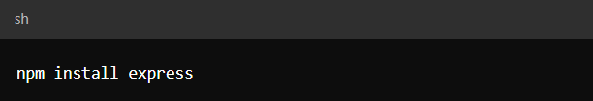npm install express

Ensure that Node.js is installed first.

1. Once installed, create a JavaScript file (e.g., index.js) and write the following code:
2. 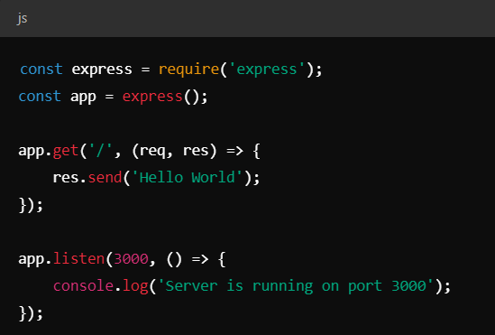Run the server using:

sh

CopyEdit

node index.js

1. Open your browser and go to http://localhost:3000. You should see "Hello World".

To create additional routes, modify the code:

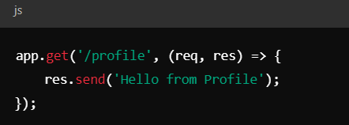Restart the server, and when you visit http://localhost:3000/profile, you will see "Hello from Profile".

**Understanding Middleware in Express.js**

Middleware is a function that runs **before** a request reaches its final route handler. It is useful for logging, authentication, error handling, and more.

**How Middleware Works**

Middleware functions have access to the request (req), response (res), and next function. The next function passes control to the next middleware or route handler.

Example:

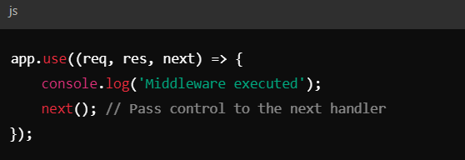Now, every request will log "Middleware executed" before processing further.

**Example of a Full Express.js Application with Middleware**

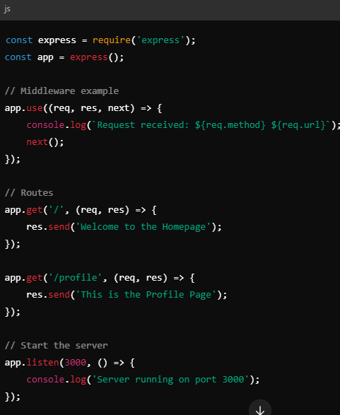When you visit / or /profile, the middleware will log the request details before sending a response.

**Conclusion**

Express.js makes backend development easier by providing:  
✅ Simple routing  
✅ Middleware for pre-processing requests  
✅ Efficient handling of HTTP requests and responses

This passage explains how to create dynamic routes in JavaScript, specifically using Express.js. Here's a simplified English version of what it's saying:

**Understanding Dynamic Routes in Express.js**

1. **Basic Route Setup:**
   * If you create a route like /profile/harsh, it will only work for "harsh".
   * If you try /profile/harshita, it will give an error.
2. **Making Routes Dynamic:**
   * To make the route work for any username, use a **route parameter**:
   * 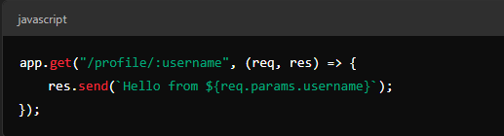
3. **Accessing Parameters:**
   * Express stores route parameters in req.params.
   * Example:
   * 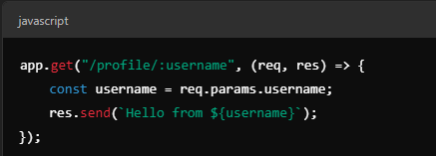This dynamically updates the response based on the URL.
4. **Using Template Literals:**
   * To make string formatting easier, use **backticks (``)**:
   * 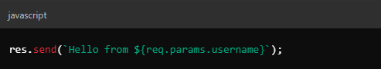If you don't understand this, you might need to learn JavaScript basics first.

**Template Engines (EJS)**

* HTML by itself cannot perform calculations.
* Template engines like **EJS (Embedded JavaScript)** allow you to use JavaScript inside HTML.
* Steps to set up **EJS**:

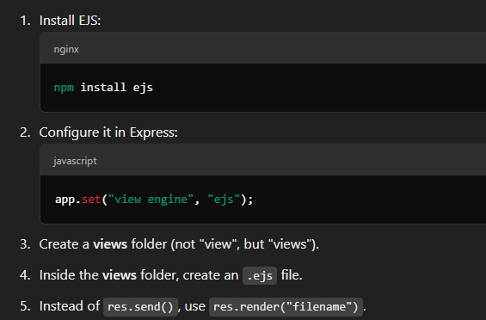Now,

Here’s a cleaned-up and structured version of your entire chat, translated into English:

**Contact Page and About Page Discussion**

* You copied and pasted content into a section.
* You discussed showing a separate page for the contact form rather than rendering the index page.
* A new page was created for /contact, and boilerplate code was pasted inside.
* Rendering logic was adjusted so that visiting /contact would show the correct content instead of the index page.

**Template Engines Overview**

* Template engines help convert a particular markup style into HTML.
* The engine in use is **EJS (Embedded JavaScript Templates)**, which looks similar to HTML.
* Unlike raw HTML, EJS allows embedding dynamic data and logic inside templates.
* Other template engines include **Pug (formerly Jade)**, **Handlebars**, and **JST**.
* Pug and JST use Python-like syntax with indentation, while EJS closely resembles traditional HTML.

